Zilu DONG z5096599

Toby HUANG z5141448

Hui LIN z5167876

Yufei ZHAO z5098342

Project report

SENG2011

Requirements

The following requirements list will be prioritised using the MoSCoW notation:

- [Priority 1]: Signifies ‘Must Have’ features. These are requirements that are critical to the success or failure of the “Fine Food Finder” system.

- [Priority 2]: Signifies ‘Should Have’ features. These are requirements that the development team have signified as important but not necessary.

- [Priority 3]: Signifies ‘Could Have’ features. These are requirements that have been deemed desirable but not crucial. It is possible that in a further release of the product these features could be developed, but it is unlikely to be added in the first release.

- [Priority 4]: Signifies ‘Won’t Have’ features. These are requirements that the development team have denoted as the least critical. It is unlikely that the features will be implemented in the foreseeable future. However, the addition of these features will still have a positive impact on the product.

*Poster*

A poster is someone who wants to post a task on PartyWhip and choose the bidder he/she desires.

1. [Priority 1] Posters can post one or more requests of food provision
   1. [Priority 1] Posters must specify basic parameters for requests
      1. [Priority 1] name and message of the request
      2. [Priority 1] number of people
      3. [Priority 1] location
      4. [Priority 1] date and time
      5. [Priority 1] food types
      6. [Priority 2] the closing time of bids //couldn’t be later than event time
      7. [Priority 1] budget for whole event
      8. [Priority 1] status of the request // change by the progress (incl. Processing, Deal, Finished, Cancelled)
   2. [Priority 2] Posters can specify some other parameters
      1. [Priority 2] A post can only select one parameter value for a field (Couldn’t have multiple parameters with one field)
      2. [Priority 2] Poster can see all the provided parameters
2. [Priority 1] Posters can view requests they posted // Even if it is finished
   1. [Priority 1] Posters can view all requests they posted in a list // sorted by status
      1. [Priority 3] Posters can sort the requests by the date
      2. [Priority 2] Posters can filter requests by their status
      3. [Priority 4] Posters can sort the requests by the latest bid
      4. [Priority 4] Posters can filter requests by some other parameters
   2. [Priority 1] Posters can choose bidders for an open request // change state
      1. [Priority 2] bidders will be sorted based on their bidding price and bidding time
      2. [Priority 2] Poster can see all bidders’ comments written by previous posters.
      3. [Priority 3] Poster can view bidders’ information on bidders’ profile // Only bidders who bid this post and the post is not in state Finished or Cancelled
      4. [Priority 2] When a request is overdue, it should be automatically cancelled // changing the state
      5. [Priority 3] Posters can evaluate a bidder after a request is completed
         1. [Priority 3] Poster can only rate his post
         2. [Priority 3] The rate should be one to five stars in integers
         3. [Priority 3] Posters can rate the bidder for this request
         4. [Priority 4] Posters can write comments to this bidder
      6. [Priority 3] Poster will see the recommend stars of all the bidders who bid the post.
         1. [Priority 3] The recommend starts is based on the rate of other posters’ rate to this bidder
         2. [Priority 3] The recommend starts is based on the parameters of this posts.
         3. [Priority 3] Appear 0 rate if these rules are not applied, such as there’s no rate to this bidder, this bidder has done nothing about the given parameter of this post.
   3. [Priority 1] Posters can manage his posts
      1. [Priority 1] Posters can cancel a processing or deal state request which created by themselves // change state, need to verify
      2. [Priority 2] Posters can edit details of a request created by themselves and not in state Finished or Cancelled // change states of bidders needs to verify
      3. [Priority 2] Posters can regret for selecting a bidder 6 hours prior the service requesting time
3. [Priority 1] Posters can register and log in
   1. [Priority 3] Posters can edit and provide contact details
      1. [Priority 3] Phone number
      2. [Priority 3] Email
      3. [Priority 3] Name
      4. [Priority 3] Address
      5. [Priority 4] Additional information

*Parameter*

1. [Priority 1] Parameters can only be CRUD (Change Read Update Delete) by admin
   1. [Priority 1] Parameters cannot be hard deleted // need to verify, implement by a deleted state in Parameters
2. [Priority 2] Parameter is a key-value pair, including // created admin
   1. [Priority 2] nature of event
   2. [Priority 2] level of food quality
   3. [Priority 2] special diet
   4. [Priority 2] religious restriction
   5. [Priority 2] provision of alcohol
   6. [Priority 2] age profile
   7. [Priority 2] kitchen size
   8. [Priority 2] indoor/outdoor
   9. [Priority 3] additional provision of crockery/glasses/cutlery/chairs

*Bidder*

Bidder is a user who wants to bid a task and finish the post when he/she is chosen by the poster.

1. [Priority 1] Bidders can view a list of posted requests
   1. [Priority 2] Default list is sorted by relevant rate // need to verify
   2. [Priority 2] Bidders can sort requests
      1. [Priority 2] sort by latest bidding price
      2. [Priority 2] sort by latest bidding time
      3. [Priority 2] sort by relevance
   3. [Priority 2] Bidders can filter requests
      1. [Priority 2] filter by food type
      2. [Priority 2] filter by region
      3. [Priority 2] filter by due time
      4. [Priority 2] filter by other parameters
   4. [Priority 4] Bidders can only see requests with food types they can provide
2. [Priority 1] Bidders can place bids on requests
   1. [Priority 1] Bid need to provide the offer budget and leave some comments
   2. [Priority 4] get notification when a bid update
3. [Priority 1] Bidders can register and log in
   1. [Priority 3] Bidder must have a profile
      1. [Priority 3] Bidder can edit its own profile // only bidder and poster can edit
         1. [Priority 3] including contact details
         2. [Priority 3] including the information of restaurant (if applicable)
         3. [Priority 3] including food types they can provide
         4. [Priority 3] including past photos of catering services they provided
         5. [Priority 3] including their prefer time for service provision (help to match the post more effectively)
   2. [Priority 3] Bidders can view posters’ contact information when they have been selected for the posters’ requests
      1. [Priority 3] Only can view the detail at Deal state of the corresponding post

*Admin*

Admin can access all the necessary data to manage the website and provide customer service.

1. [Priority 3] Admin can log into a system different from bidder and poster
   1. [Priority 3] Admin can delete the account of bidders and posters
   2. [Priority 3] Admin can CRUD all Post and Bid
   3. [Priority 3] Admin can CRUD all Parameters

Use Cases

***Use Case 1:***

Post a request

Actor:

User (Poster)

Basic Flow:

The user logged in as a poster, he/she can go to a page which is unreachable by a bidder or an admin. The poster selects Post New Request and the website is redirected to a new page. The user may wish to fill out following parameters - nature of event, level of food quality, special diet, religious restriction, provision of alcohol, age profile, kitchen size, indoor or outdoor, as well as additional provision of crockery/ glasses/cutlery/chairs. After clicking Confirm, the request is posted.

***Use Case 2:***

Bid a request

Actor:

User (Bidder)

Basic Flow:

The user logged in as a bidder, he/she can go to a page which is unreachable by a poster or an admin. The bidder browses a list of posted requests that are suitable to the user. This list of posts can be further sorted and filtered by different parameters, such as latest bidding price and time, relevance, food type, region, request due time. The bidder selects Bid Request for the desired posted request and he/she will be redirected to a new page. The bidder can see a list of bids that have been made and needs to make a bid that is lower than the latest bid (or the budget if no bid has been made). After entering the bidding price, the bidder clicks Confirm, and the bid is made.

***Use Case 3:***

Choose a Bid

Actor:

User (Poster)

Basic Flow:

The user logged in as a poster, he/she can go to a page which is unreachable by a bidder or an admin. The poster can select a created post that the user wishes to decide the bidder. When the poster browses through all bids for the request, he/she can see their bid price and any comment made by each bidder. The poster can also select any bidder in the bidding list to view their profiles. This includes the bidder’s contact details, average rank rated by other users, comments written by other users and some personal information. After that, the user selects the desired bidder, and the bidder will be notified. During the dealing stage, the chosen bidder can also view the poster’s profile.

Alternative Flow:

If the poster did not choose a bidder before the due date of the request, the request will be changed to Close state automatically.

***Use Case 4:***

Registration

Actor:

User

Basic Flow:

If a user wishes to become a poster or a bidder, then he/she will need to register an account to utilise the website features. The user clicks Register button on the main page and will be redirected to a new page specified for registration. The registration for poster and bidder is different: a poster needs to provide contact details such as name, residential address, phone number and email address, as well as any necessary additional information; while for a bidder, not only these contact information, he/she also needs to provide food specialty, past photos of provided catering services and preferred time for service provision.

***Use Case 5:***

Website Management

Actor:

Admin

Basic Flow:

After admin is logged in, he/she can go to a page which cannot be reached by poster and bidder. The admin page allows admin to explore all necessary data for website management and provision of customer service. This includes managing user accounts, posts, parameters and bids.

***Use Case 6:***

Evaluate a bidder

Actor:

User (Poster)

Basic Flow:

After the chosen bidders complete the task posted by the user, the user can rate the bidders according to his or her satisfaction level. In addition, the user can write comments to the bidders once the bidders complete the task.

***Use Case 7:***

View posts

Actor:

User (Poster)

Basic Flow:

The user logged in as a poster, he/she can go to a page which is unreachable by a bidder or an admin. The poster browses through a list of created posts, then he/she can click a specific post and see the details of the post and biddings list.

Alternative Flow 1:

When user browses the list of created posts, he/she can select one or more key parameters and filters the list of posts by the chosen key. Then only posts that satisfies these conditions will be shown.

Alternative Flow 2:

When user browses the list of created posts, he/she can select one or more parameter such as last bidding date and then sort the list of posts by the parameter.

***Use Case 8:***

Edit post detail

Actor:

User (Poster)

Basic Flow:

The user logged in as a poster, he/she can go to a page which is unreachable by a bidder or an admin. The poster can select a specific post from post list, if the post is not in the state Finished or Cancelled, then the user can choose to edit all the details and extra parameters of this post. Then all the bids of this post will be suspended, which means the user won’t be allowed to choose from these suspended bids. Bidders should get notified and make new bids for this task.

***Use Case 9:***

Regret a post

Actor:

User (Poster)

Basic Flow:

The user logged in as a poster, he/she can go to a page which is unreachable by a bidder or an admin. The poster can select a specific post from post list, if the post is in the Processing or Dealing state and it’s more than 6 hours prior the service provision time, then the user can choose to regret choosing this bidder. Then this chosen bidder will be notified about it, and the post will be in Open State Again. Then all the bids of this post will be suspended, which means the user won’t be allowed to choose from these suspended bids. Bidders should get notified and make new bids for this task.

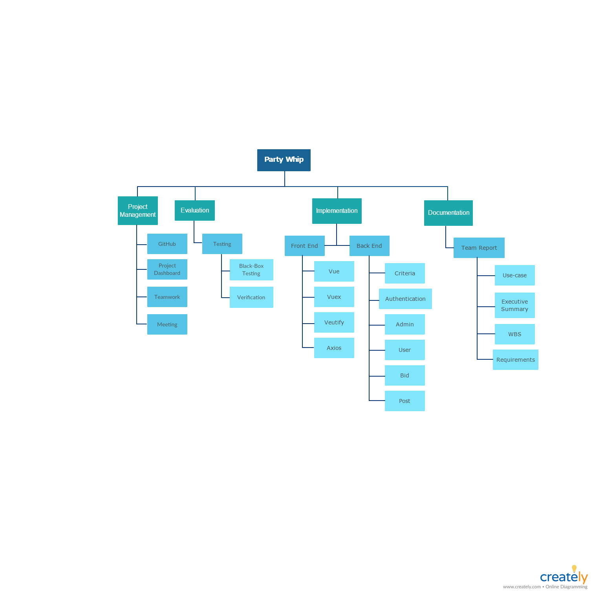Work Breakdown Structure